### Create Partner Code Group (Reward Item Group) Flow

**Overview of steps**

1. Step1 - Upload file
2. Step2 - Create Reward Item Group
3. Step3 - Publish REWARD_ITEM_GROUP_CREATED.v1 and consume it
4. Step4 - Publish REWARD_ITEM_GROUP_DEPLOYED.v1 and consume it

### **Step1 -** Upload file

|  |  |
| --- | --- |
| **Repo** | [dtcloyalty-admin-rewardsadmin-filemanager](https://dev.azure.com/PepsiCoIT/PEPCommerce_Loyalty/_git/dtcloyalty-admin-rewardsadmin-filemanager) |
| **API Endpoint** | <http://localhost:8080/files/upload> |
| **Example Parameters** | program_id=018a2bd5-fdc2-77ce-9367-7d700186d5ae partner_id=8834025b-b51d-4669-9973-200f07a9ed54 |
| **Body** | **Key** = file **Type** = File **Value** = File to be uploaded |

**Sample file**

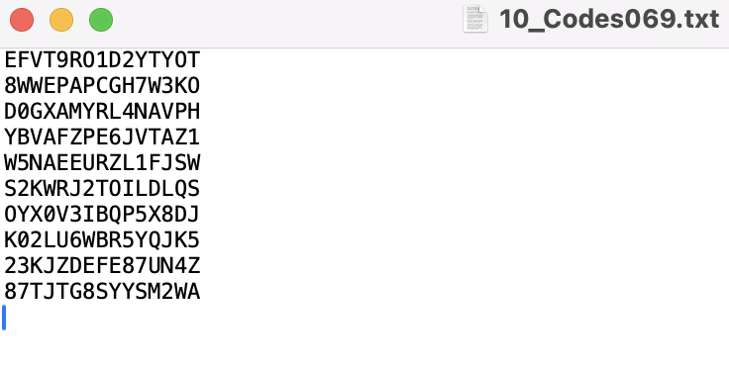

**Request**

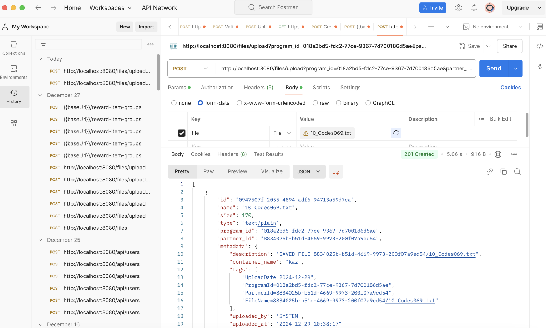

**API Response**

|  |
| --- |
| [  {  "id": "0947507f-2055-4894-adf6-94713a59d7ca",  "name": "10_Codes069.txt",  "size": 170,  "type": "text/plain",  "program_id": "018a2bd5-fdc2-77ce-9367-7d700186d5ae",  "partner_id": "8834025b-b51d-4669-9973-200f07a9ed54",  "metadata": {  "description": "SAVED FILE 8834025b-b51d-4669-9973-200f07a9ed54/10_Codes069.txt",  "container_name": "kaz",  "tags": [  "UploadDate=2024-12-29",  "ProgramId=018a2bd5-fdc2-77ce-9367-7d700186d5ae",  "PartnerId=8834025b-b51d-4669-9973-200f07a9ed54",  "FileName=8834025b-b51d-4669-9973-200f07a9ed54/10_Codes069.txt"  ],  "uploaded_by": "SYSTEM",  "uploaded_at": "2024-12-29 10:38:17"  }  }  ] |

### **Step2 -** Create Reward Item Group

|  |  |
| --- | --- |
| **Repo** | [dtcloyalty-admin-rewardsadmin-rewardsmanager](https://dev.azure.com/PepsiCoIT/PEPCommerce_Loyalty/_git/dtcloyalty-admin-rewardsadmin-rewardsmanager) |
| **API Endpoint** | <http://localhost:8080/reward-item-groups> |

**Sample Request Body**

|  |
| --- |
| {  "name": "KZrewarditemgroup145",  "description": "KZrewarditemgroup145",  "program_id": "018a2bd5-fdc2-77ce-9367-7d700186d5ae",  "partner_id": "8834025b-b51d-4669-9973-200f07a9ed54",  "code_warning_limit_percentage": 80,  "reward_item_file_data": [  {  "id": "5de33ce2-1919-445e-afda-78c28ecbcab8",  "name": "10_Codes069.txt",  "size": 170,  "type": "text/plain",  "program_id": "018a2bd5-fdc2-77ce-9367-7d700186d5ae",  "partner_id": "8834025b-b51d-4669-9973-200f07a9ed54",  "metadata": {  "description": "SAVED FILE 8834025b-b51d-4669-9973-200f07a9ed54/10_Codes06.txt",  "container_name": "kaz",  "tags": [  "UploadDate=2024-12-27",  "FileName=8834025b-b51d-4669-9973-200f07a9ed54/10_Codes06.txt",  "ProgramId=018a2bd5-fdc2-77ce-9367-7d700186d5ae",  "PartnerId=8834025b-b51d-4669-9973-200f07a9ed54"  ],  "uploaded_by": "SYSTEM",  "uploaded_at": "2024-12-27 23:15:33"  }  }  ],  "is_active": true,  "start_date": "2024-10-28T08:03:18",  "end_date": "2025-07-12T08:03:18"  } |

**API Response**

|  |
| --- |
| {  "reward_item_file_data": [  {  "name": "10_Codes069.txt",  "size": 170,  "reward_item_group_id": "d475ae59-66a4-489e-82dc-7efc1b3dc877",  "metadata_id": "2fd2ce3a-d0f4-4140-812b-eff226b29b3b",  "metadata": {  "tags": [  "UploadDate=2024-12-27",  "FileName=8834025b-b51d-4669-9973-200f07a9ed54/10_Codes06.txt",  "ProgramId=018a2bd5-fdc2-77ce-9367-7d700186d5ae",  "PartnerId=8834025b-b51d-4669-9973-200f07a9ed54"  ],  "container_name": "kaz",  "uploaded_by": "SYSTEM",  "uploaded_at": "2024-12-27 23:15:33",  "description": "SAVED FILE 8834025b-b51d-4669-9973-200f07a9ed54/10_Codes06.txt",  "id": "2fd2ce3a-d0f4-4140-812b-eff226b29b3b"  },  "id": "b75c4af3-8e77-4f0d-bbfa-cd14f55e9c81"  }  ],  "name": "KZrewarditemgroup145",  "description": "KZrewarditemgroup145",  "partner_id": "8834025b-b51d-4669-9973-200f07a9ed54",  "program_id": "018a2bd5-fdc2-77ce-9367-7d700186d5ae",  "code_warning_limit_percentage": 80,  "is_active": true,  "exhausted_code": 0,  "code_count": 0,  "is_imported": false,  "start_date": "2024-10-28T08:03:18",  "end_date": "2025-07-12T08:03:18",  "id": "d475ae59-66a4-489e-82dc-7efc1b3dc877",  "status": "INACTIVE",  "processing_status": "IMPORTING"  } |

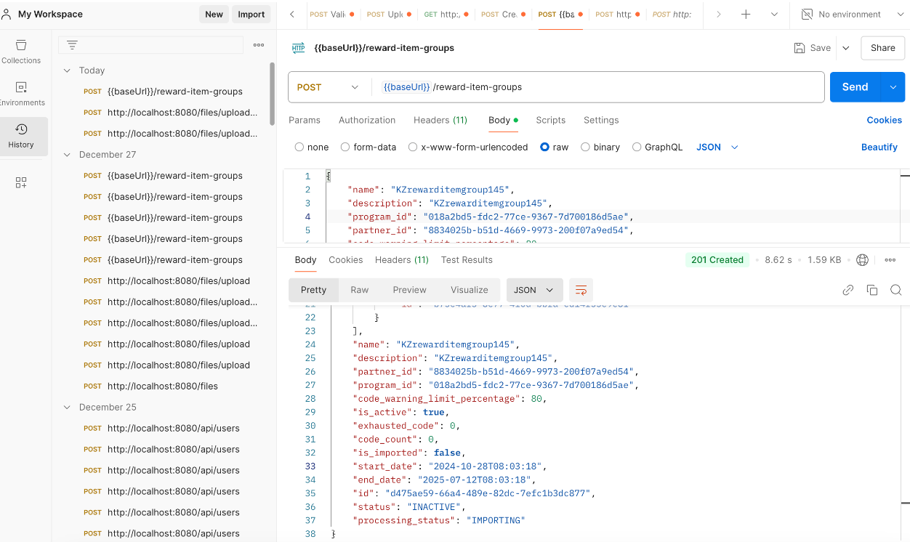

### **Step3 -** Publish REWARD_ITEM_GROUP_CREATED.v1 and consume it

Run below repo locally to consume an event

|  |  |
| --- | --- |
| **Repo** | [dtcloyalty-runtime-consumerrewards-deployment-service](https://dev.azure.com/PepsiCoIT/PEPCommerce_Loyalty/_git/dtcloyalty-runtime-consumerrewards-deployment-service) |
| **Raise event** | Login to [ServiceBus](https://portal.azure.com/" \l "@pepsico.onmicrosoft.com/resource/subscriptions/8a22bd18-1080-472c-a8af-da15be88b076/resourceGroups/pep-dop-nonprod-gwc-01-rg/providers/Microsoft.ServiceBus/namespaces/pep-cep-kz-gwc-dev/topics/dtc-loyalty-sb-consumerrewards-outbound/subscriptions/loyalty-dtcloyalty-rewards-test/explorer) |
| **Event type** | com.pepsico.dtcloyalty.configurationnadmin.REWARD_ITEM_GROUP_CREATED.v1 |
| **Message body type** | application/json |
| **Session Id** | 1234 |
| **Send message** | Sample payload given below |

**Sample Payload**

|  |
| --- |
| {  "specversion": "1.0",  "id": "ao1026e003a-a103ca-a33da-b1130b-0d8a27ba35a106",  "source": "com.pepsico.dtcloyalty.adminrewarditemgroup",  "type":"com.pepsico.dtcloyalty.configurationnadmin.REWARD_ITEM_GROUP_CREATED.v1",  "datacontenttype": "application/json",  "dataschema": "",  "time": "2024-11-30T11:24:59.7377393Z",  "messagepublishingscope": "DOMAIN_EXTERNAL",  "data": {  "reward_item_file_data": [  {  "name": "10_Codes069.txt",  "size": 170,  "type": "text/plain",  "metadata_id": "bd918371-9665-4194-88c7-ee42d09929f9",  "reward_item_group_id": "6080bcf1-f4fb-429e-9234-0e8a9090549b",  "metadata": {  "tags": [  "UploadDate=2024-12-27",  "FileName=8834025b-b51d-4669-9973-200f07a9ed54/10_Codes06.txt",  "ProgramId=018a2bd5-fdc2-77ce-9367-7d700186d5ae",  "PartnerId=8834025b-b51d-4669-9973-200f07a9ed54"  ],  "container_name": "kaz",  "uploaded_by": "SYSTEM",  "uploaded_at": "2024-12-27 23:15:33",  "description": "SAVED FILE 8834025b-b51d-4669-9973-200f07a9ed54/10_Codes06.txt",  "id": "bd918371-9665-4194-88c7-ee42d09929f9"  },  "id": "f39a4f5f-ace7-4bcc-a691-a03708d67d3f"  }  ],  "name": "KZrewarditemgroup141",  "description": "KZrewarditemgroup141",  "partner_id": "8834025b-b51d-4669-9973-200f07a9ed54",  "program_id": "018a2bd5-fdc2-77ce-9367-7d700186d5ae",  "code_warning_limit_percentage": 80,  "is_active": true,  "exhausted_code": 0,  "code_count": 0,  "is_imported": false,  "start_date": "2024-10-28T08:03:18",  "end_date": "2025-07-12T08:03:18",  "id": "6080bcf1-f4fb-429e-9234-0e8a9090549b",  "status": "INACTIVE",  "processing_status": "IMPORTING"  }  } |

Now submitting this event message should be consumed by our local running deployment service

### **Step4 -** Publish REWARD_ITEM_GROUP_DEPLOYED.v1 and consume it

Run below repo locally to consume an event

|  |  |
| --- | --- |
| **Repo** | [dtcloyalty-admin-rewardsadmin-rewarditemprocessor](https://dev.azure.com/PepsiCoIT/PEPCommerce_Loyalty/_git/dtcloyalty-admin-rewardsadmin-rewarditemprocessor) |
| **Raise event** | Login to [ServiceBus](https://portal.azure.com/" \l "@pepsico.onmicrosoft.com/resource/subscriptions/8a22bd18-1080-472c-a8af-da15be88b076/resourceGroups/pep-dop-nonprod-gwc-01-rg/providers/Microsoft.ServiceBus/namespaces/pep-cep-kz-gwc-dev/topics/dtc-loyalty-sb-consumerrewards-outbound/subscriptions/loyalty-dtcloyalty-rewards-test/explorer) |
| **Event type** | com.pepsico.dtcloyalty.consumerrewards.REWARD_ITEM_GROUP_DEPLOYED.v1 |
| **Message body type** | application/json |
| **Session Id** | 1234 |
| **Send message** | Sample payload given below |

**Sample Payload**

|  |
| --- |
| {  "specversion": "1.0",  "id": "ao1026e003a-a103ca-a33da-b1130b-0d8a27ba35a106",  "source": "com.pepsico.dtcloyalty.adminrewarditemgroup",  "type": "com.pepsico.dtcloyalty.consumerrewards.REWARD_ITEM_GROUP_DEPLOYED.v1",  "datacontenttype": "application/json",  "dataschema": "",  "time": "2024-11-30T11:24:59.7377393Z",  "messagepublishingscope": "DOMAIN_EXTERNAL",  "data": {  "reward_item_file_data": [  {  "name": "10_Codes06.txt",  "size": 170,  "type": "text/plain",  "meta_data_id": "bd918371-9665-4194-88c7-ee42d09929f9",  "reward_item_group_id": "6080bcf1-f4fb-429e-9234-0e8a9090549b",  "metadata": {  "tags": [  "UploadDate=2024-12-27",  "FileName=8834025b-b51d-4669-9973-200f07a9ed54/10_Codes06.txt",  "ProgramId=018a2bd5-fdc2-77ce-9367-7d700186d5ae",  "PartnerId=8834025b-b51d-4669-9973-200f07a9ed54"  ],  "container_name": "kaz",  "uploaded_by": "SYSTEM",  "uploaded_at": "2024-12-27 23:15:33",  "description": "SAVED FILE 8834025b-b51d-4669-9973-200f07a9ed54/10_Codes06.txt",  "id": "bd918371-9665-4194-88c7-ee42d09929f9"  },  "id": "f39a4f5f-ace7-4bcc-a691-a03708d67d3f"  }  ],  "name": "KZrewarditemgroup141",  "description": "KZrewarditemgroup141",  "partner_id": "8834025b-b51d-4669-9973-200f07a9ed54",  "program_id": "018a2bd5-fdc2-77ce-9367-7d700186d5ae",  "code_warning_limit_percentage": 80,  "is_active": true,  "exhausted_code": 0,  "code_count": 0,  "is_imported": false,  "start_date": "2024-10-28T08:03:18",  "end_date": "2025-07-12T08:03:18",  "id": "6080bcf1-f4fb-429e-9234-0e8a9090549b",  "status": "INACTIVE",  "processing_status": "IMPORTING"  }  } |

Now submitting this event message should be consumed by our local running rewarditemprocessor service

## Key tables involved

| **Schema** | **Table** |
| --- | --- |
| rewardsmanager | rewards_item_group |
| rewardsmanager | rewards_item_group_file_data |
| rewardsmanager | rewards_item_group_file_meta_data |
| RUNTIME_CONSUMER_REWARDS | rewards_item_group |
| RUNTIME_CONSUMER_REWARDS | rewards_item_group_file_data |
| RUNTIME_CONSUMER_REWARDS | rewards_item_group_file_meta_data |

## Trouble shooting tips

## ****Error while downloading file in Step4****

## Download the certificate of the blob storage URL and install it locally. Command Example keytool -import

## -trustcacerts

## -keystore

## "/Users/pavanu/Library/Java/JavaVirtualMachines/openjdk23/Contents/Home/lib

## /security/cacerts"

## -storepass changeit

## -alias rewardadminfilemanagerCert

## -file "/Users/kavyasrutiputrevu/Downloads/_.global.gw01.aks01.gwc.nonprod.azure.intra.pepsico.com.pem"

## ****Event publishing fails****

## Ensure to provide a unique ID in the event payload.